Nicole

Harrison

|  |  |
| --- | --- |
| A tree in a grassy field  Description automatically generated  Savana Project Weather and Flux towers  Documentation | Abstract  This document contains information related to installation, maintenance and provenance of data from weather station and flux tower at Sonora, Martin, and Read ranches.  Aline Jaimes, PhD |

Contents

Instruments 2

Notes on Sensor Placement 4

CRBASIC Programs 10

Wiring Diagram 11

Notes of sensor placement 12

CS655 Placement – Flux Tower 12

To do 13

**List of Figures**

Figure 1. Weather station at Martin Ranch. 1. Windsonic, 2. EE=181, 3. CNR4, 4. CS655, 5. TB4, 6. CS100, 7. 034A, 8. Solar Panel. 6

Figure 2. Weather station at Read Ranch. 1. Windsonic, 2. EE=181, 3. CNR4, 4. CS655, 5. TB4, 6. CS100, 7. 034A, 8. Solar Panel. 7

Figure 3. Weather station at Sonora Ranch. 1. Windsonic, 2. EE=181, 3. CNR4, 4. CS655, 5. TB4, 6. CS100, 7. 034A, 8. Solar Panel. 9. Phenocam 8

Figure 4. Main components of the Weather Station enclosure. 1. CR1000 data logger, 2.SC100, 3.RV50 MODEM, 4. Battery and Power Controller 9

Figure 5. Instruments and power components of the Eddy Covariance Tower 10

Figure 6. Main components of the Flux Tower enclosure. 1. CR6 data logger, 2. CDM116 11

Figure 7. CS655 Placement – Sonora Ranch 12

Figure 8. CS655 Placement - Martin Ranch 12

Figure 9. CS655 Placement – Read Ranch 12

Figure 10. HF01 Placement - Martin Ranch 12

Figure 11. TCAV Placement - Martin Ranch 12

# Instruments

Table List of weather station instruments and associated variables

|  |  |  |  |  |
| --- | --- | --- | --- | --- |
|  | Model | Description | Measurement | Units |
| 1 | WindSonic4 | Two-Dimensional Ultrasonic Anemometer | Wind Speed and direction | m/s, degrees |
| 2 | EE+181 and Radiation shield | Air Temp and Relative humidity sensor | Air Temp and Relative humidity | Deg Celsius, % |
| 3 | CNR4 | Net radiometer | Short and long wave incoming and outgoing radiation | W/m^2/s |
| 4 | CS655 | Water Content reflectometer | Volumetric Water Content, Soil Temperature, Electrical conductivity | m^3/m^3, Deg Celsius, dS/m |
| 5 | TB4 | Tipping Bucket Rain Gauge | Precipitation | mm |
| 6 | CS100 | Barometric Pressure Sensor | Barometric Pressure | KPa |
| 7 | 034A/034B | Anemometer | Wind Speed and Direction | degrees |

Table List of flux tower sensors and associated variables

|  |  |  |  |  |  |
| --- | --- | --- | --- | --- | --- |
|  | Model | Description | | Measurement | Units |
| 1 | IRGASON | | Gas Analyzer and  Sonic Anemometer | Three wind components (x,y,z)  Sonic Temperature  Ambient Temperature  CO2 Density  H2O Density  Atmospheric Pressure | m/s  Degrees Celsius  Degrees Celsius  mg/m3  g/m3  kPa |
| 1 | HMP155A | | Air Temperature and Relative humidity Probe | Air Temperature  and Relative humidity | Degrees Celsius,  % |
| 1 | CNR4 | | Net radiometer | Short and long wave incoming and outgoing radiation | W/m2/s |
| 6 | CS655 | | Soil Water Content reflectometer | Soil Volumetric Water Content,  Soil Temperature,  Electrical conductivity | m3/m3,  Deg Celsius,  dS/m |
| 1 | TE525MM | | Tipping Bucket Rain Gauge | Precipitation | Mm |
| 1 | LI190 | | Quantum Sensor | Photosynthetic Active Radiation |  |
| 2 | TCAV | | Soil Thermocouple Probe | Soil Temperature | Degrees |
| 4 | HFP01 | | Soil Heat Flux Plates | Soil Heat Flux |  |

## Notes on Sensor Placement

Net radiometer and solar panel are aligned toward South.

Air Temperature and WindSonic4 sensors are placed at 15ft above ground.

Barometer is located inside the enclosure

Towers are grounded

Soil sensors and rain gauge are placed next to each other ~15 ft from the main tower. At Sonora ranch the three CS655 were spatially distributed in NW direction at approximately 5-8 cm depth. At Martin sensors were placed at depths of 5, 10, and 20 cm (see below pictures for depths/orientation of sensors).

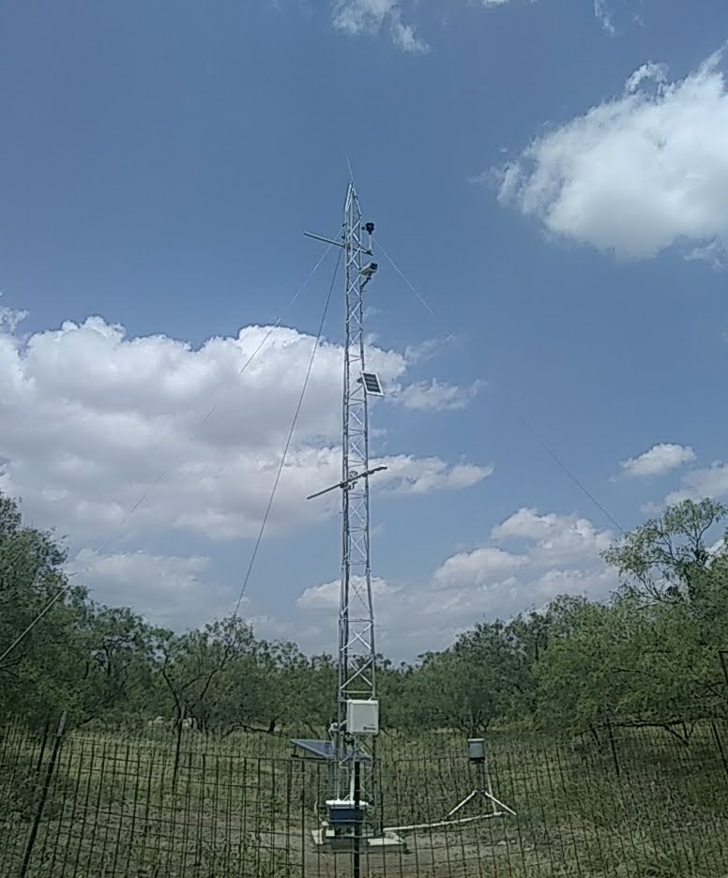

1

2

3

4

5

6

7

8

9

Figure . Weather station at Martin Ranch. 1. Windsonic, 2. EE=181, 3. CNR4, 4. CS655, 5. TB4, 6. CS100, 7. 034A, 8. Solar Panel.

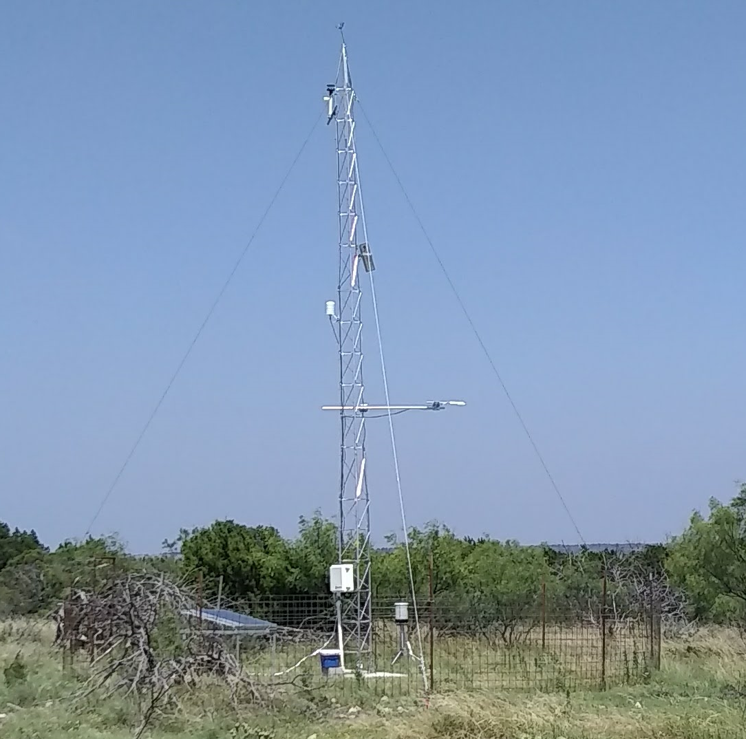

1

2

3

4

5

6

7

8

9

Figure . Weather station at Read Ranch. 1. Windsonic, 2. EE=181, 3. CNR4, 4. CS655, 5. TB4, 6. CS100, 7. 034A, 8. Solar Panel.

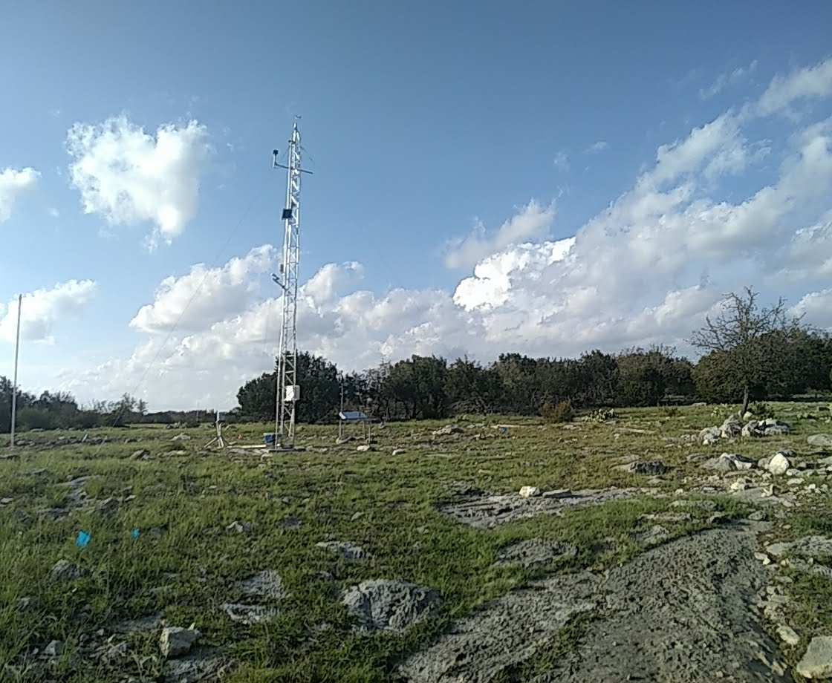

1

2

3

4

5

6

7

8

9

Figure . Weather station at Sonora Ranch. 1. Windsonic, 2. EE=181, 3. CNR4, 4. CS655, 5. TB4, 6. CS100, 7. 034A, 8. Solar Panel. 9. Phenocam

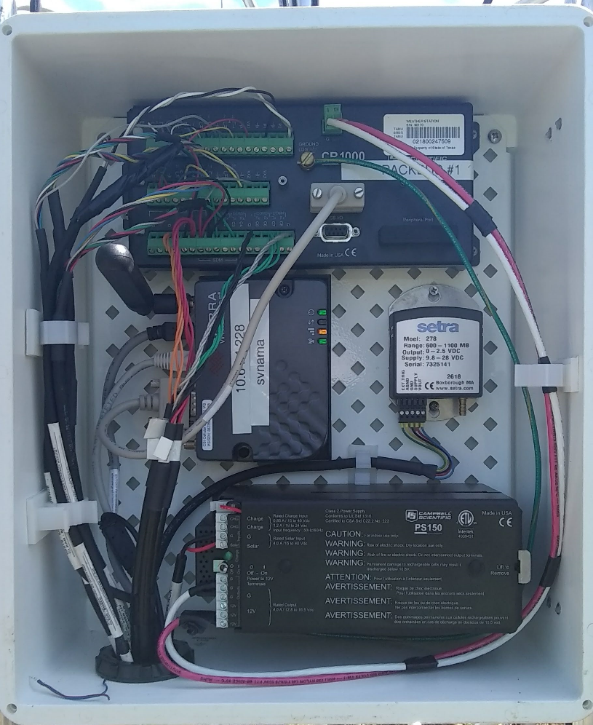

***4***

***2***

***3***

***1***

Figure . Main components of the Weather Station enclosure. 1. CR1000 data logger, 2.SC100, 3.RV50 MODEM, 4. Battery and Power Controller

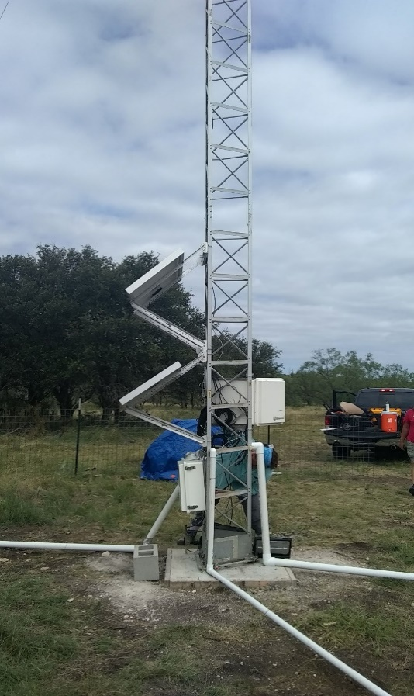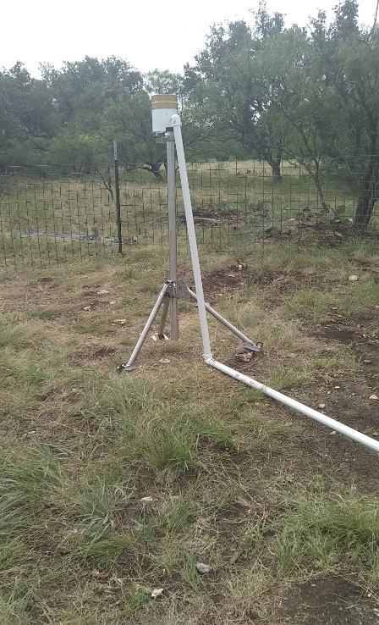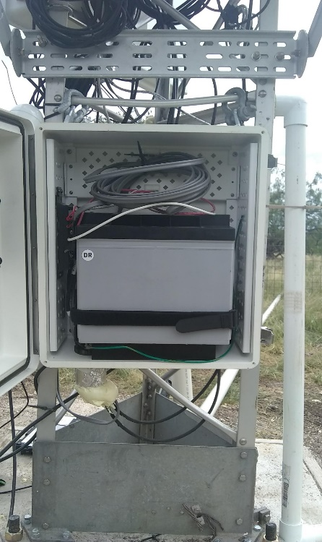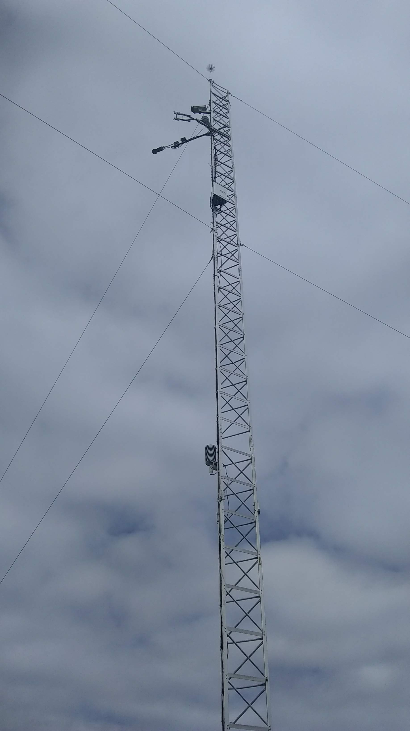

**1**

**2**

**3**

**4**

**5**

**6**

***7***

**8**

Figure . Instruments and power components of the Eddy Covariance Tower

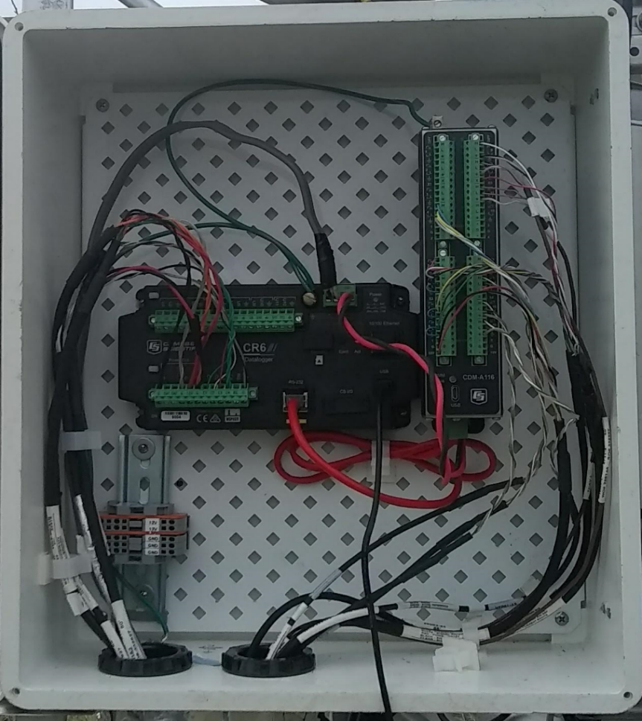

***1***

***2***

Figure . Main components of the Flux Tower enclosure. 1. CR6 data logger, 2. CDM116

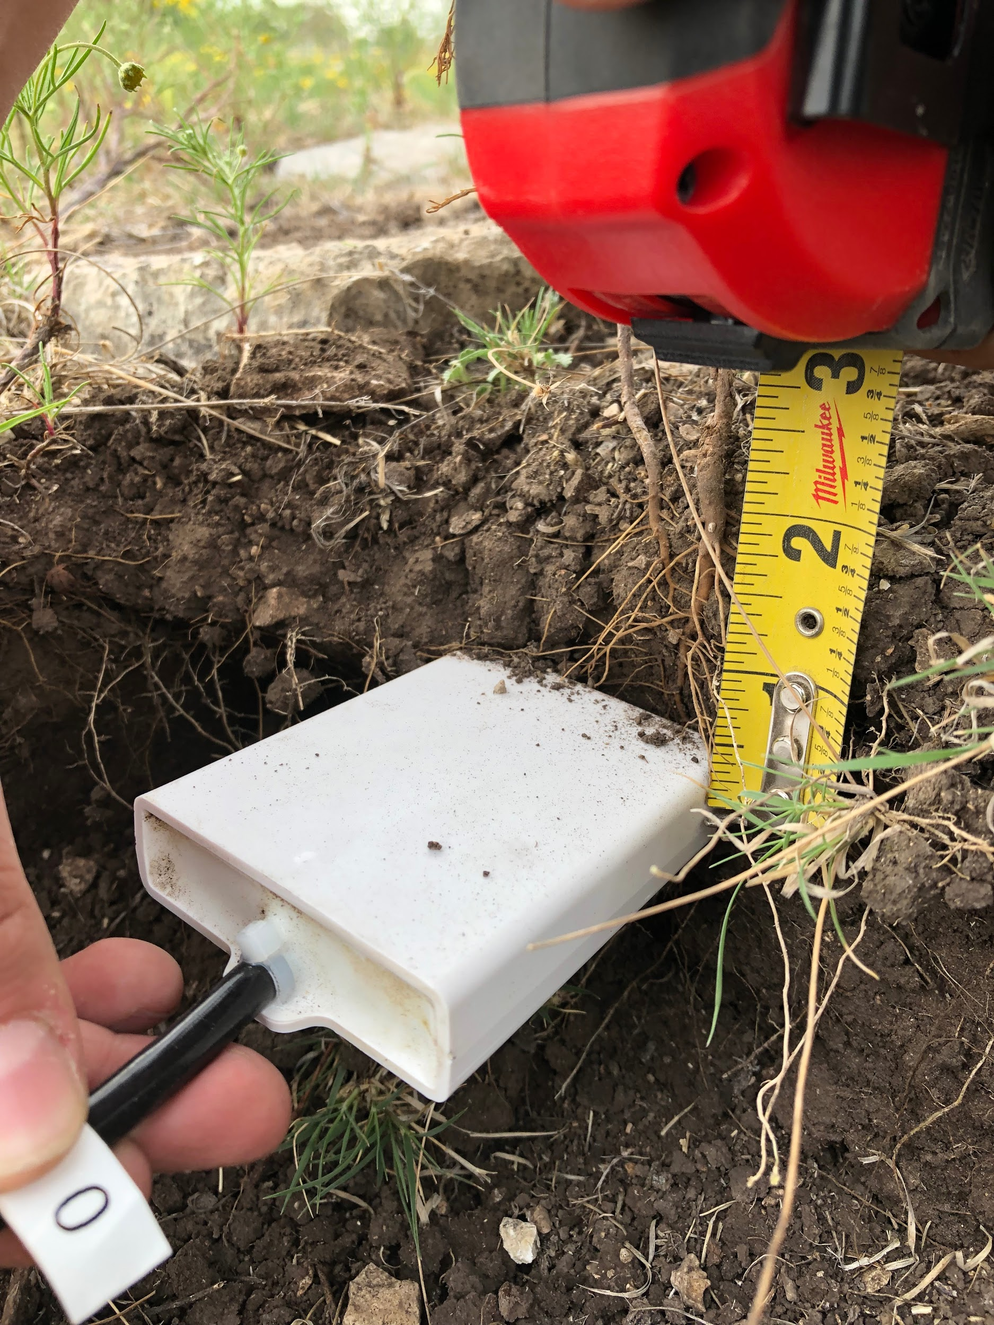 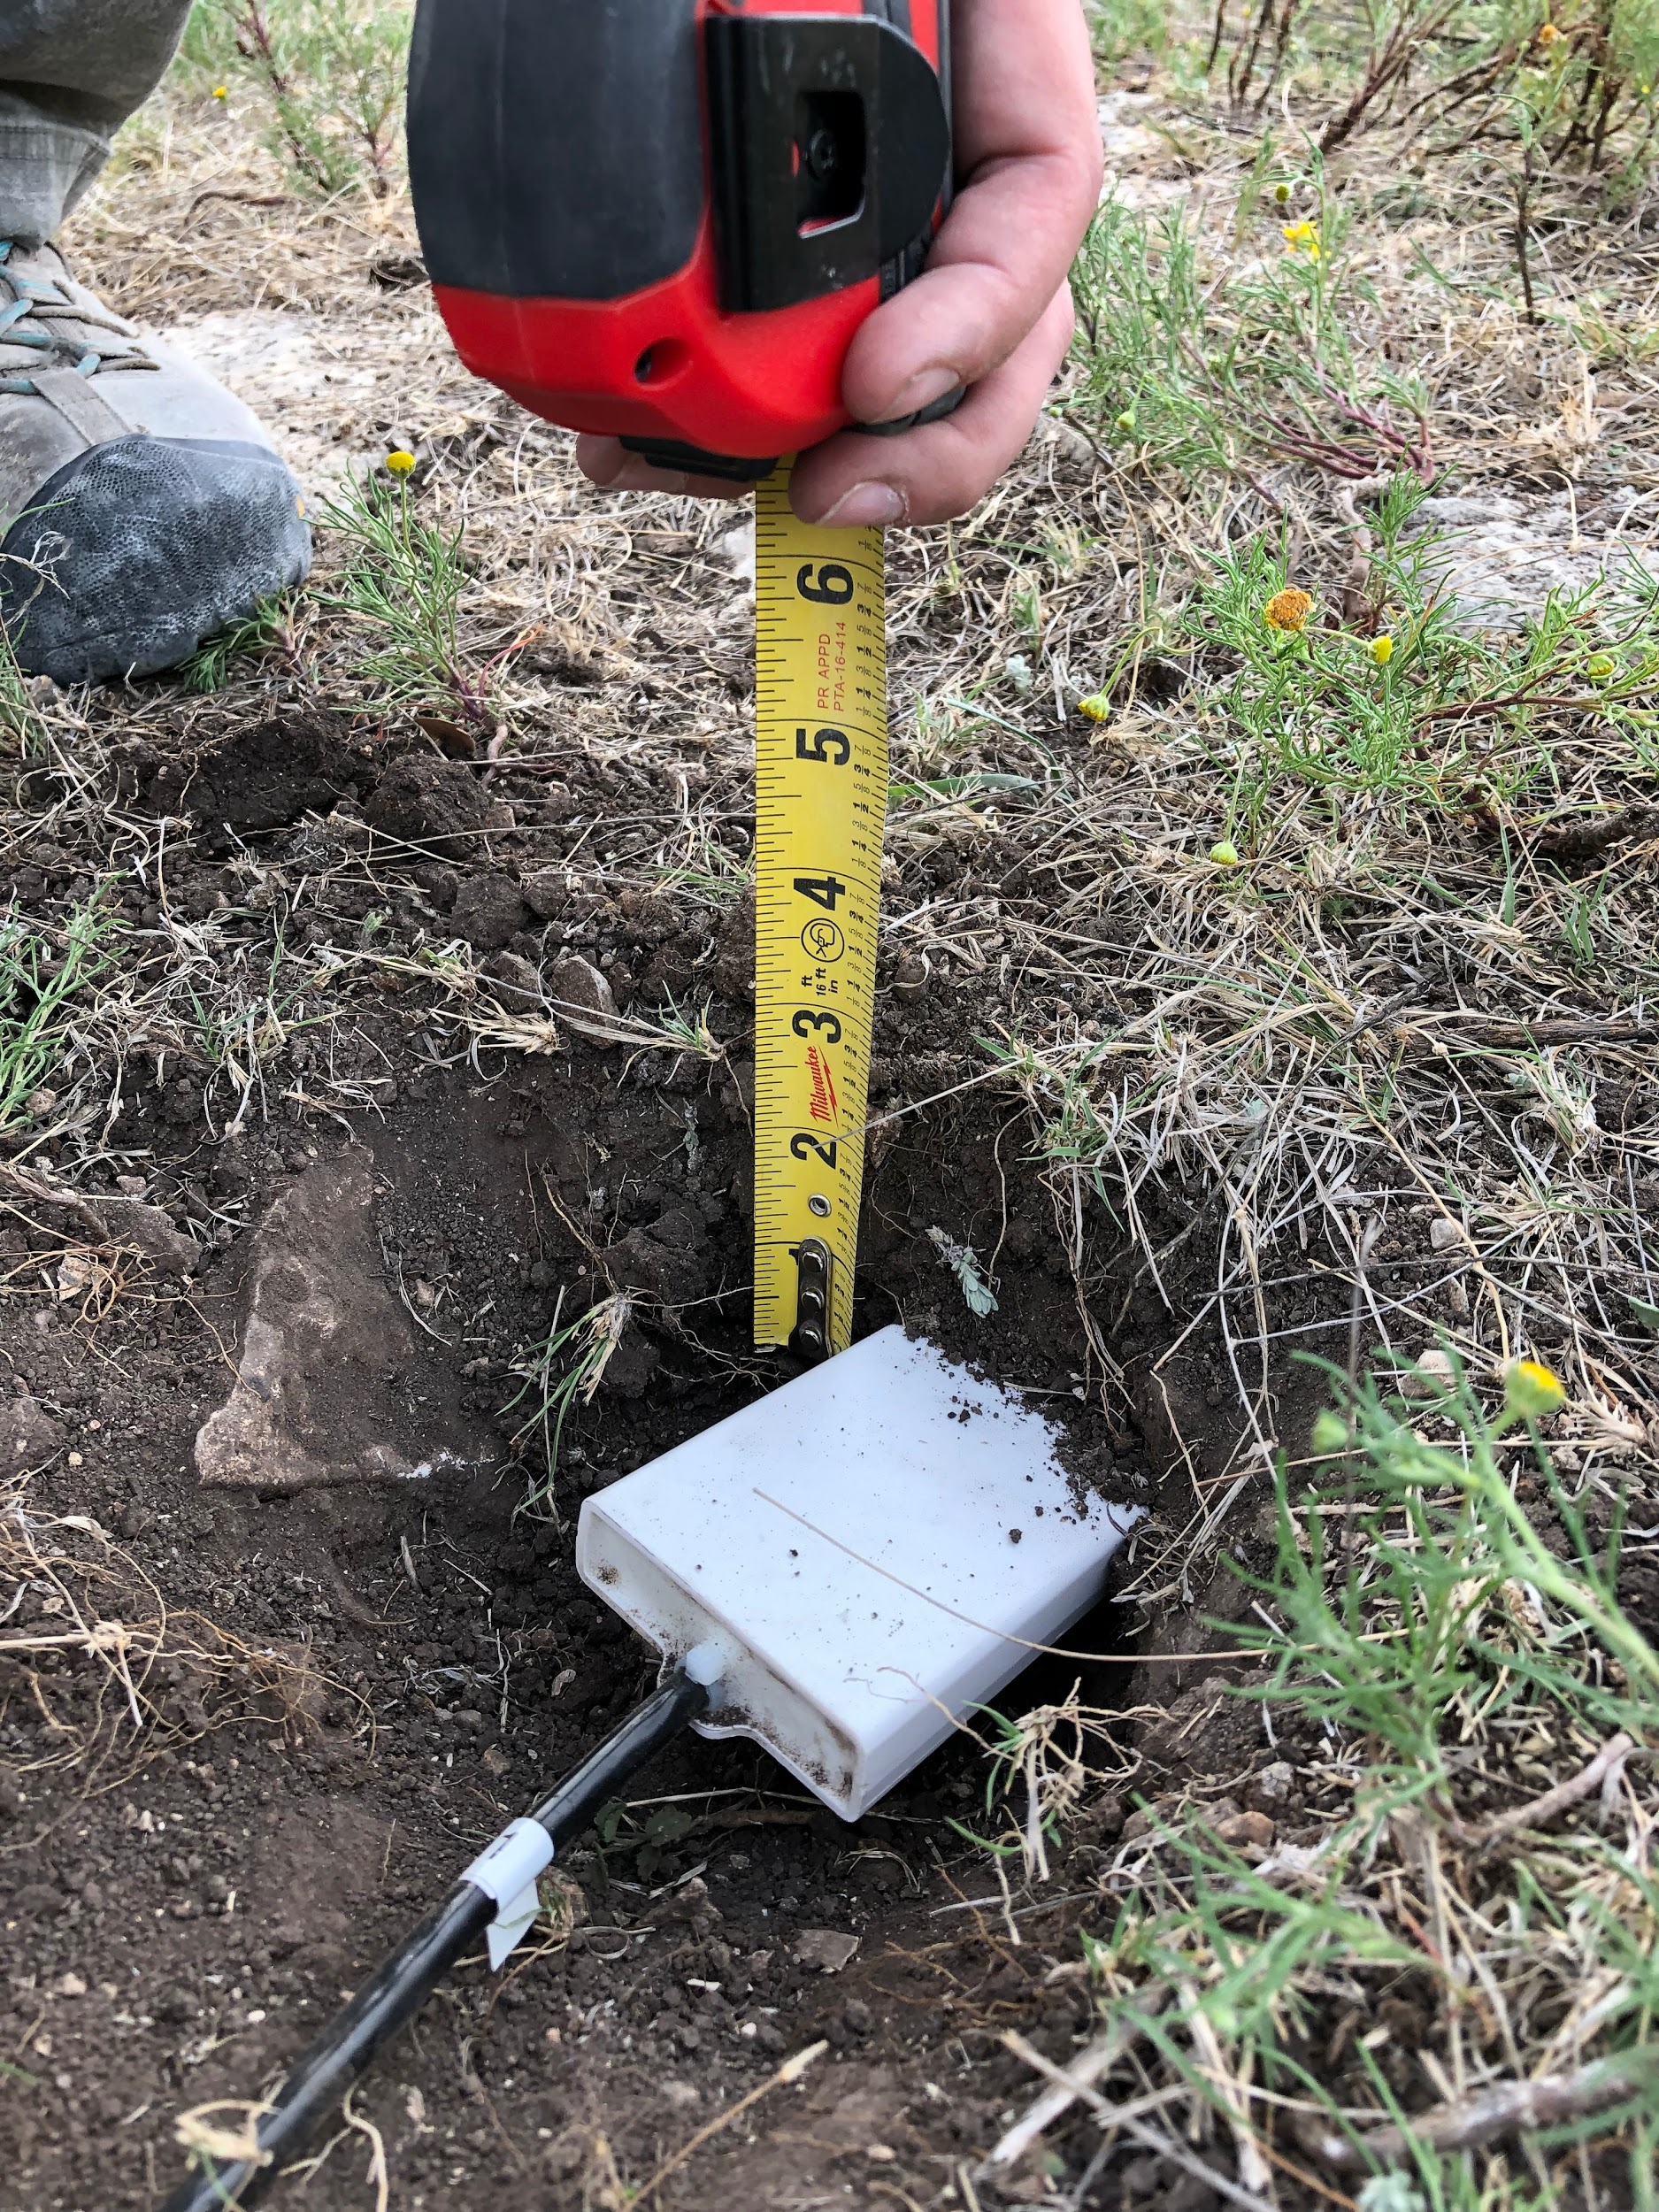 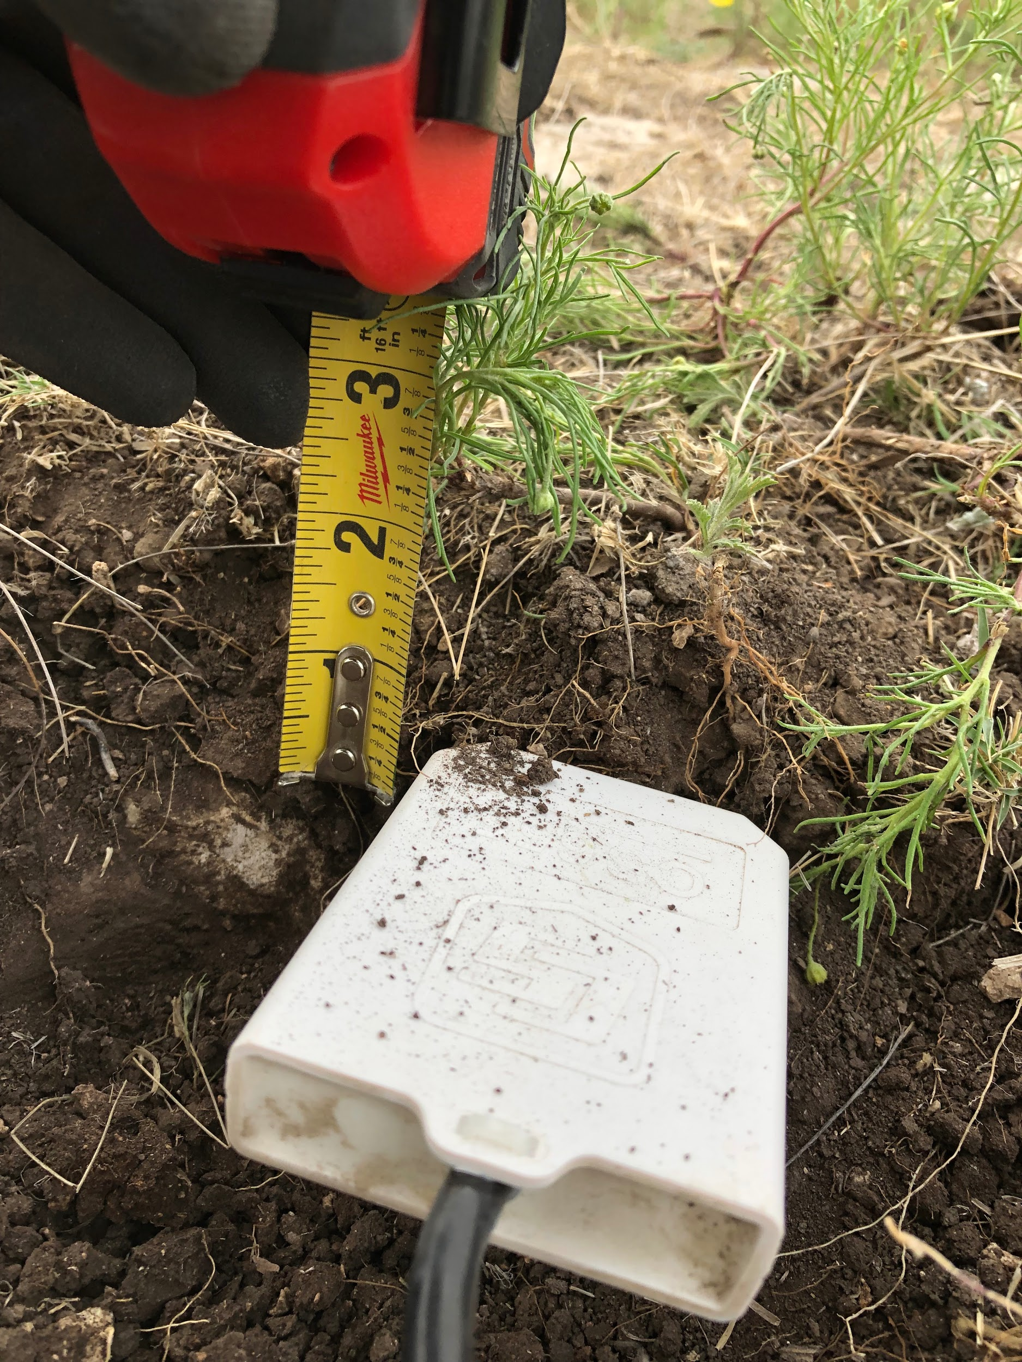

Figure . CS655 Placement – Sonora Ranch

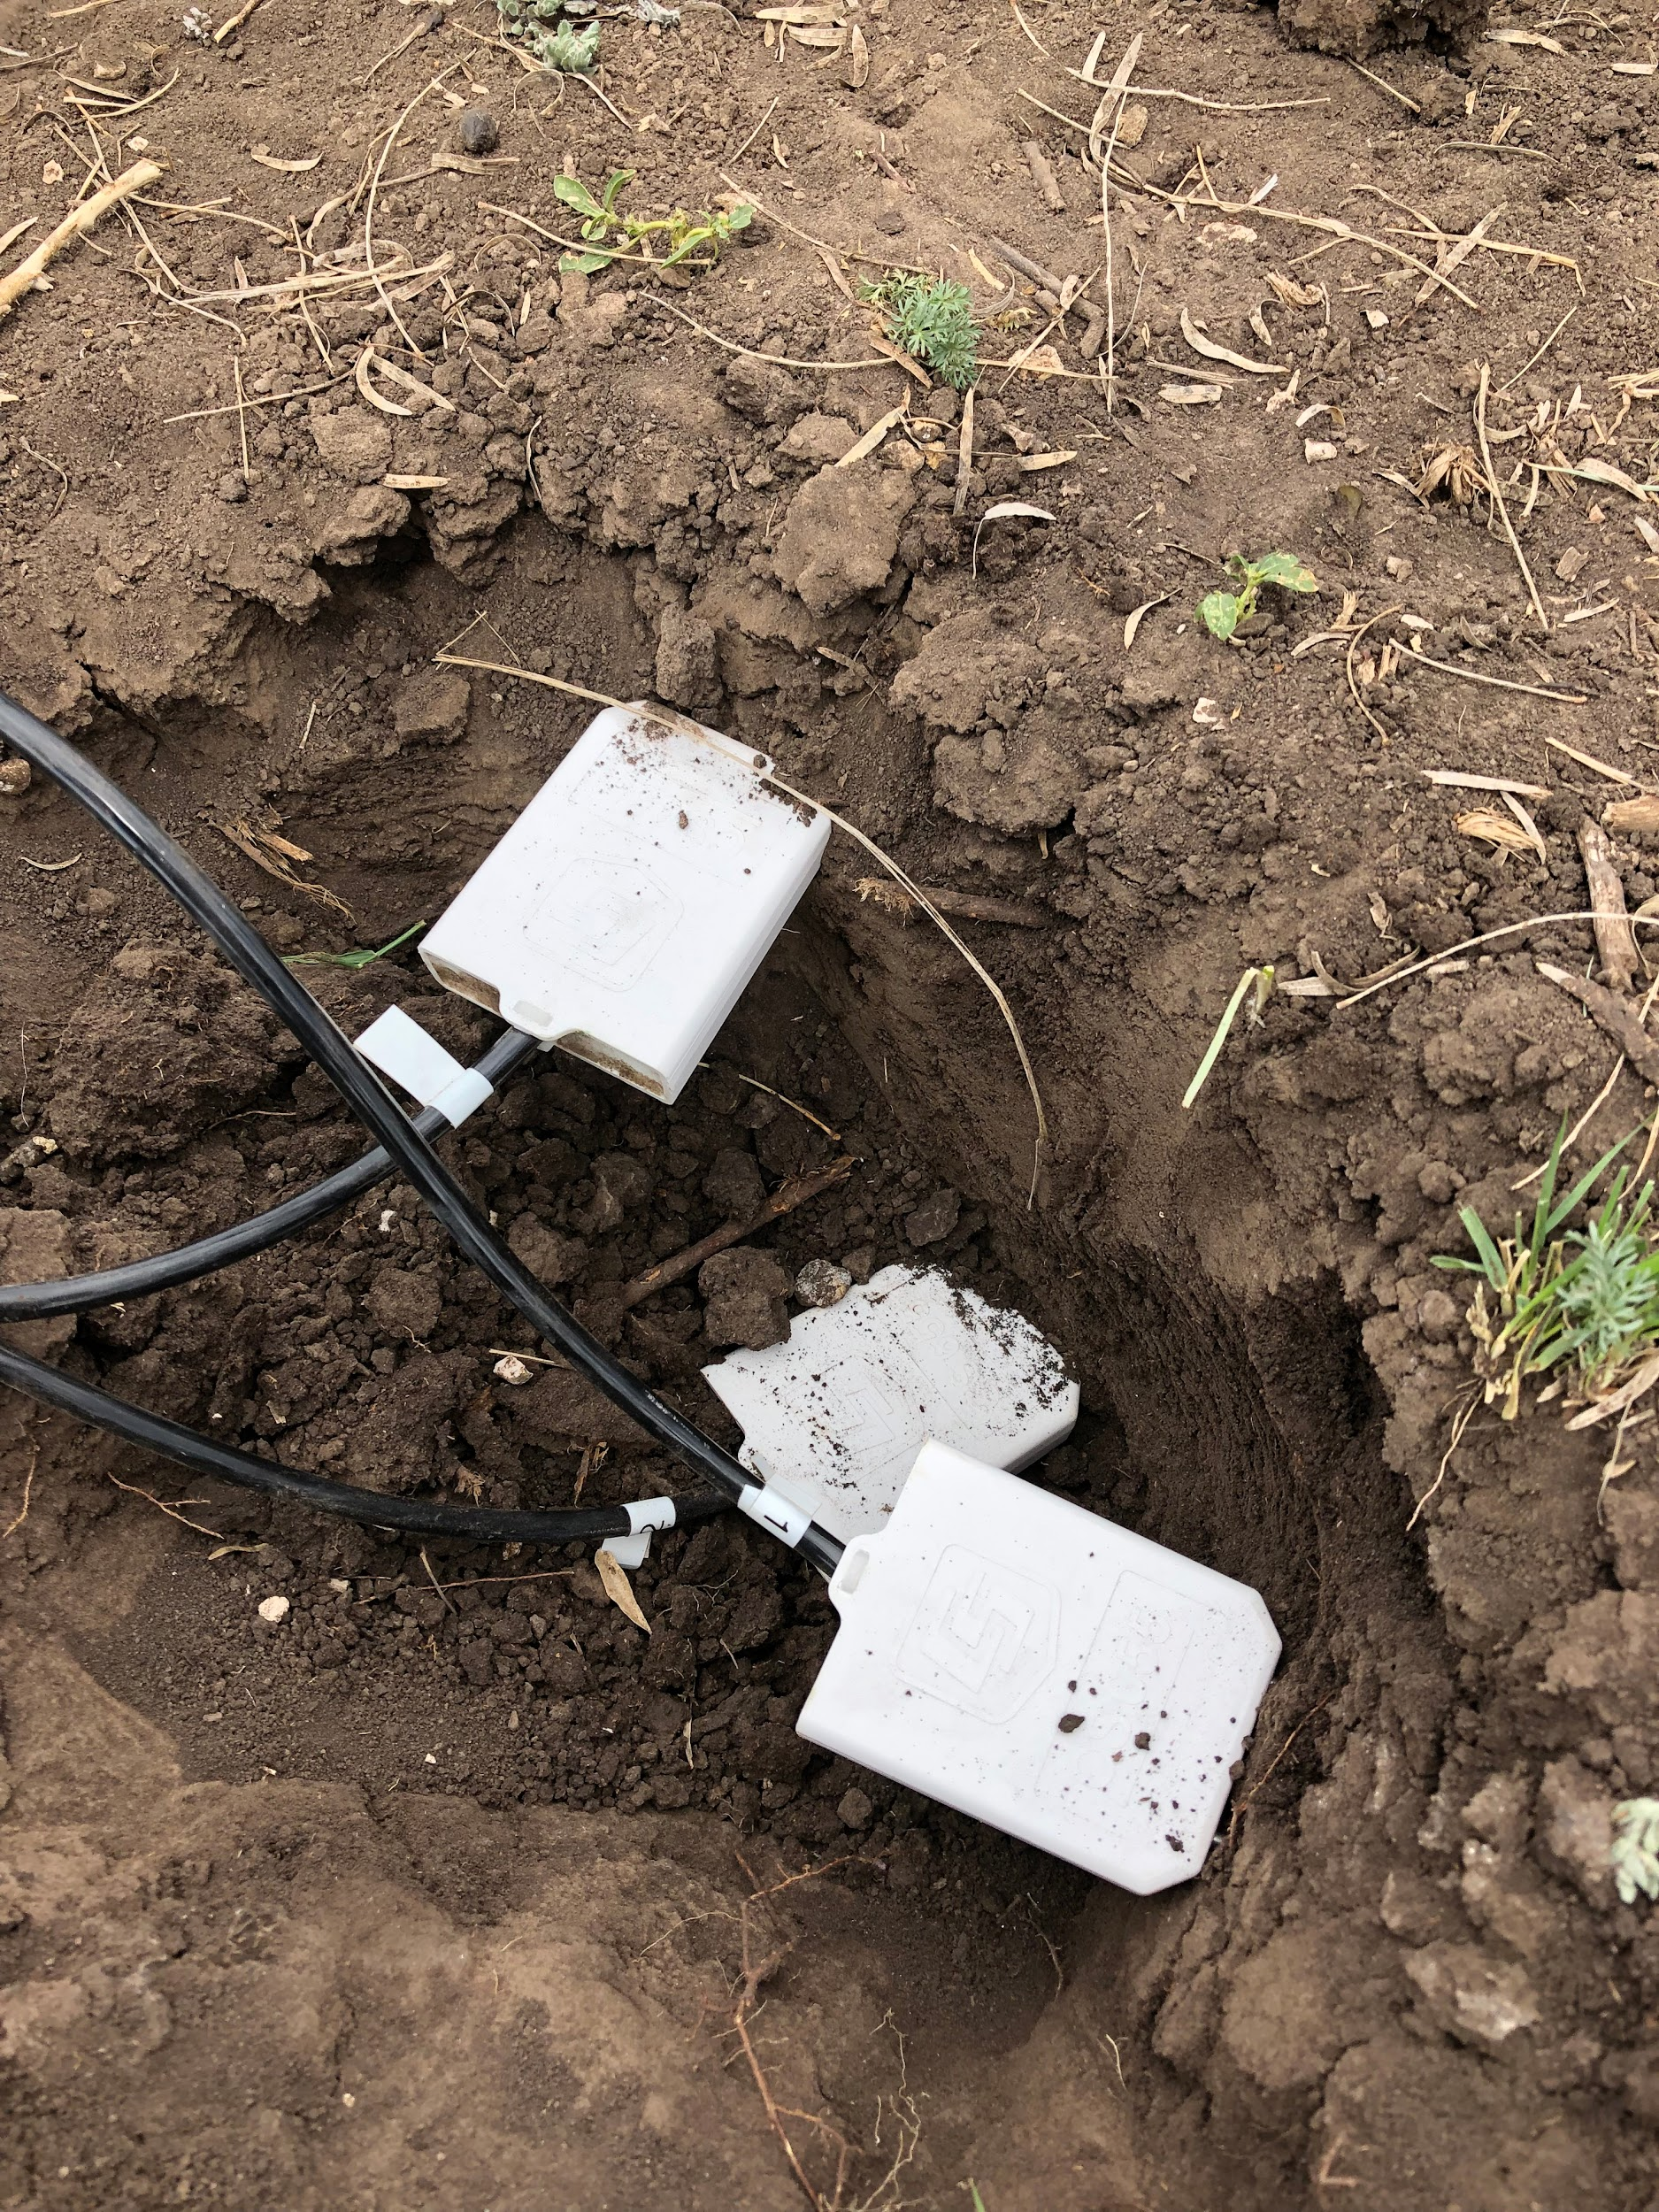

Figure . CS655 Placement - Martin Ranch

Figure . CS655 Placement – Read Ranch

Figure . HF01 Placement - Martin Ranch

Figure . TCAV Placement - Martin Ranch

## CRBASIC Programs

MartinMet.CR1

SonorMet.CR1

ReadMet.CR1

## Wiring Diagram: Weather Stations

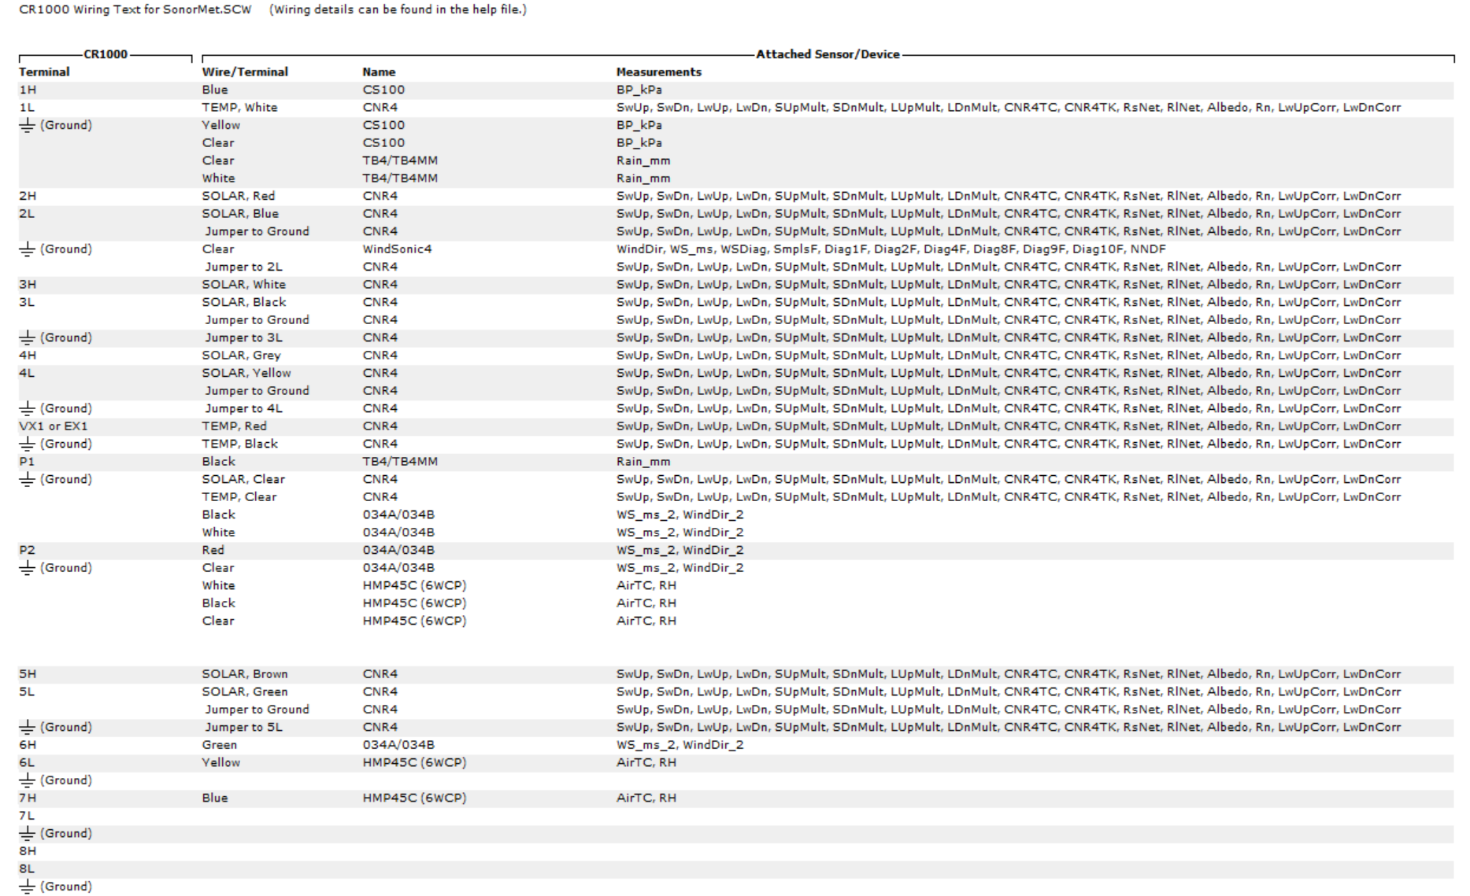

## Wiring Diagram: Flux Tower

Maintenance

## To do

|  |  |  |
| --- | --- | --- |
| Where | What | Comments |
| Martin, Read, Sonora Ranches | Phenocam Installation | Purchase Ethernet 2-wayhub |
|  | Solar Panels (3) | Kevin’s solar panels are not functional at its maximum capacity. The output was 10V at noon. These panels recharge the phenocam and modem. I am afraid the panels are not recharging the battery because I have not been able to communicate with the Modems since the weekend (June 29). |
|  | Replace cable of 034A/034B | The cable plug sent by CSI does not fit the sensor’s head. These cable needs to be returned and replaced. |
| Sonora Ranch Weather Station | WindSonic4 | Repair cable and sensor head. Soldering may be enough to repair. |
| Martin Ranch Weather Station | Attach Wi-Fi module and antenna |  |
| Flux Tower | Level PAR and CNR4  Power CDM116  Set up Modem and Antenna  Send a new CRbasic program |  |